UI EPIC | Epic Requisition Entry
This document is to provide basic instruction for the use of the new version of Requisition Entry in Epic.
How to place an order in EPIC Requisition Entry
Epic Requisition Entry | Note: Not all departments have exactly the same view of Requisition Entry. Some fields may or may not be available for editing.
Log into Epic under your department.  Open Requisition Entry under the Epic drop down menu or search for it under the Search field  .  (In BLD open Demo the New Requisition Entry) | 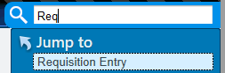  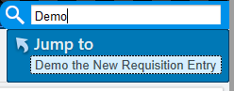
The new requisition entry has some cascading logic and certain fields will only become available after others are filled in.  - Enter a submitter in the Submitter field.  (For BLD please only use 99111)  Most submitters auto-generate a Requisition Number. For those that don’t enter an asterisk “ * “ to generate a new one.  Note: Required fields have a symbol.  Search for your patient under the Patient field by clicking the 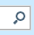  The patient lookup box will open. Enter partial/full name or MRN. Enter sex and DOB for the patient. If there is a matching patient it will be displayed.  Double click to select it.  If the patient is unlisted, exit patient lookup and create the patient in Patient Station. | 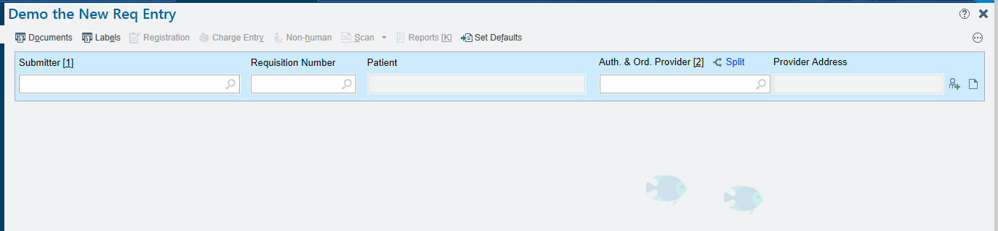  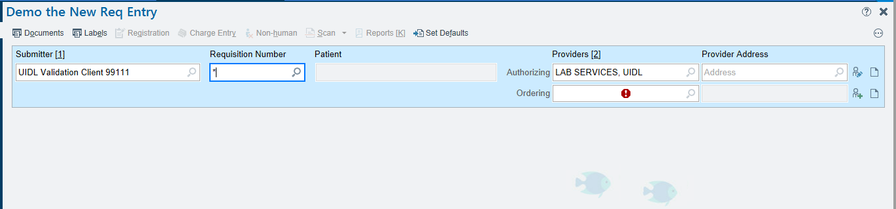  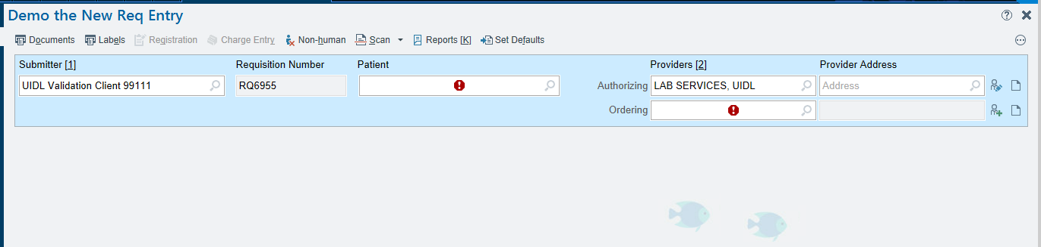  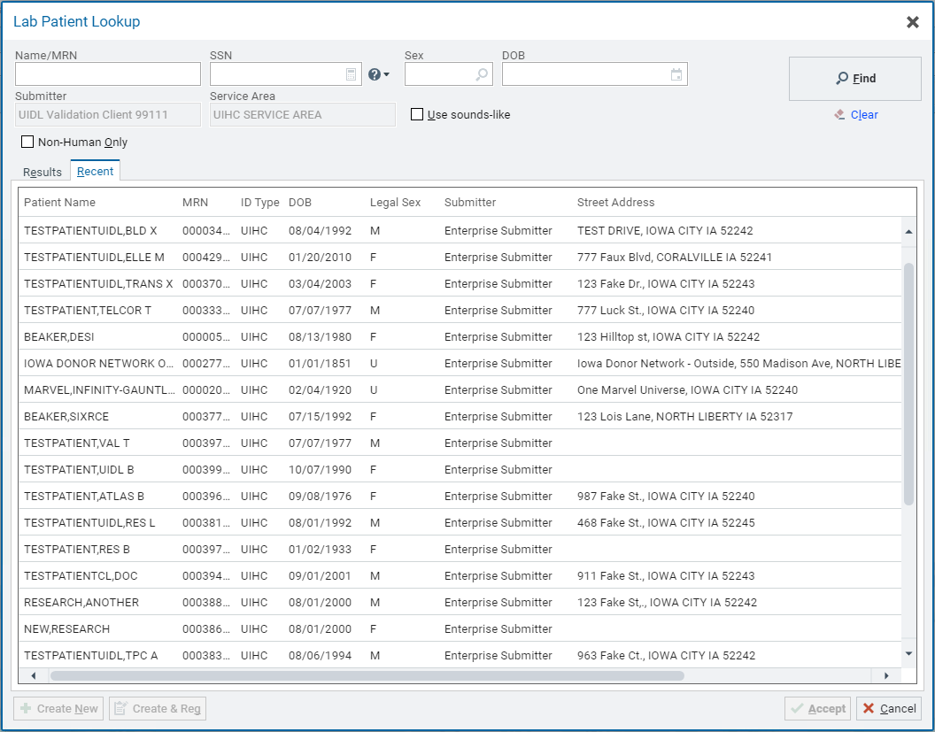
2. Once the patient is selected, new fields will become available.  Enter the ordering provider in the required field. They can be searched for using the button.  Commonly used or favorite providers can be “starred” for easier selection.  If the desired provider is not listed, they can be added using Provider on the Fly by pressing | 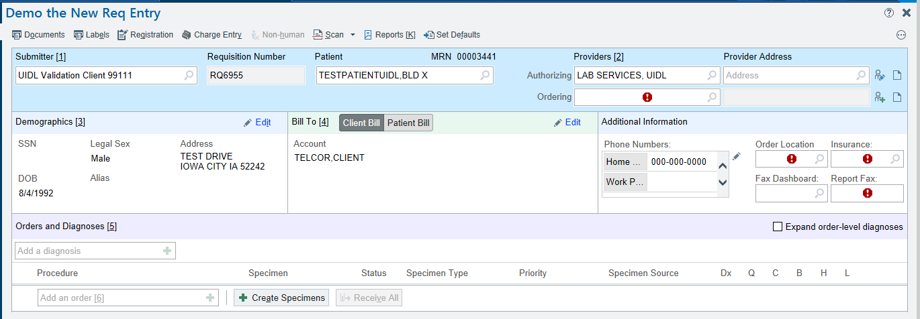  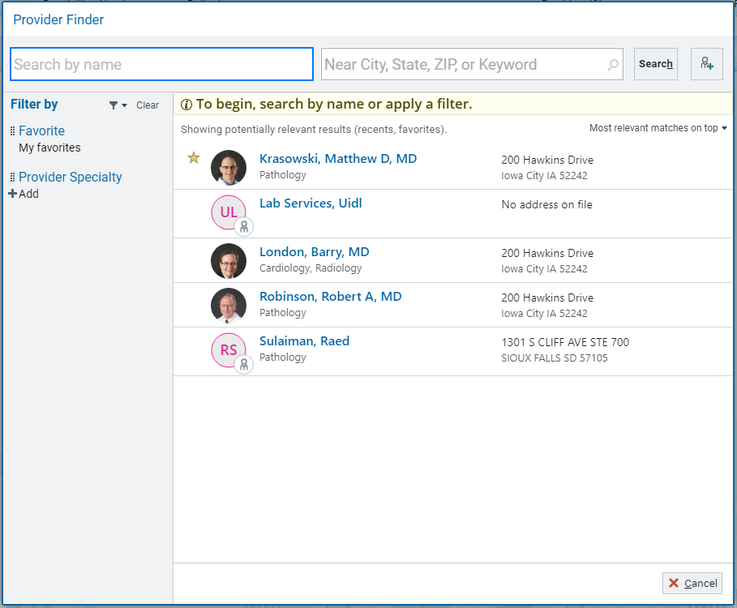  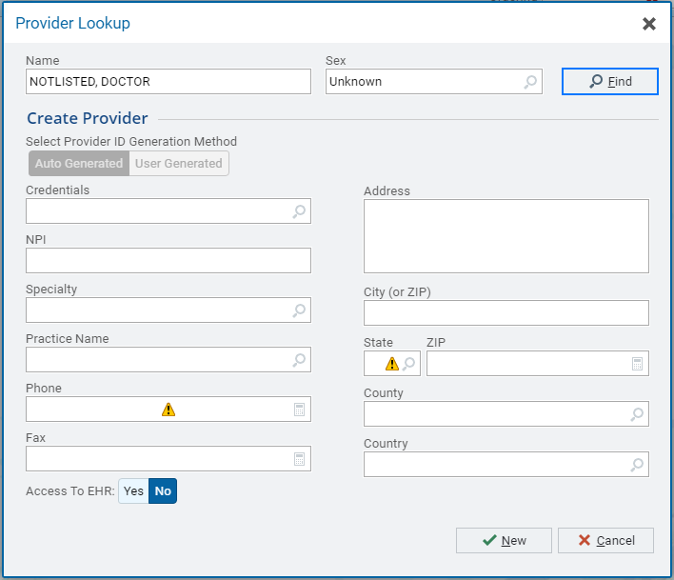
3. Address information can be entered in the newly available Demographics field.  Click the Edit Icon gain access to all fields. 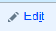  If any set demographic information is changed a prompt appears to ask why and if the patient record needs to be updated. | 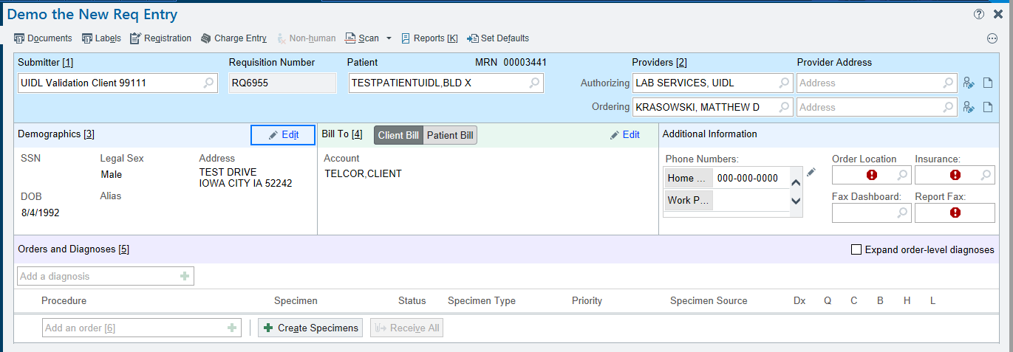  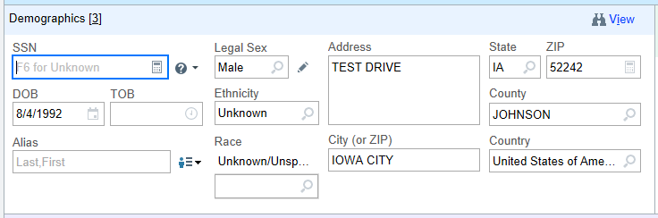  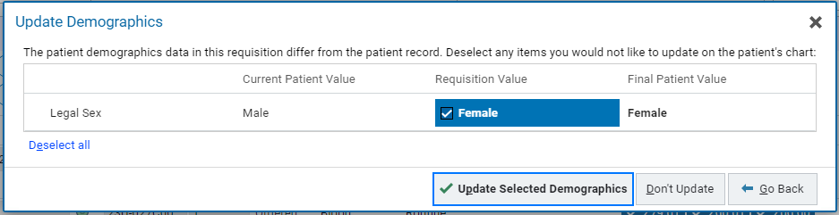  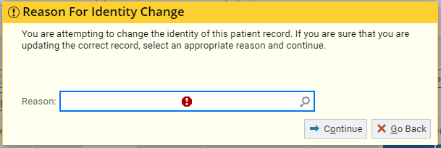
4. The Bill To field may be defaulted regarding Client versus Patient build.  The Account may be changed using the Edit icon and selecting the search feature.   Different departments may not have the ability to change these values. | 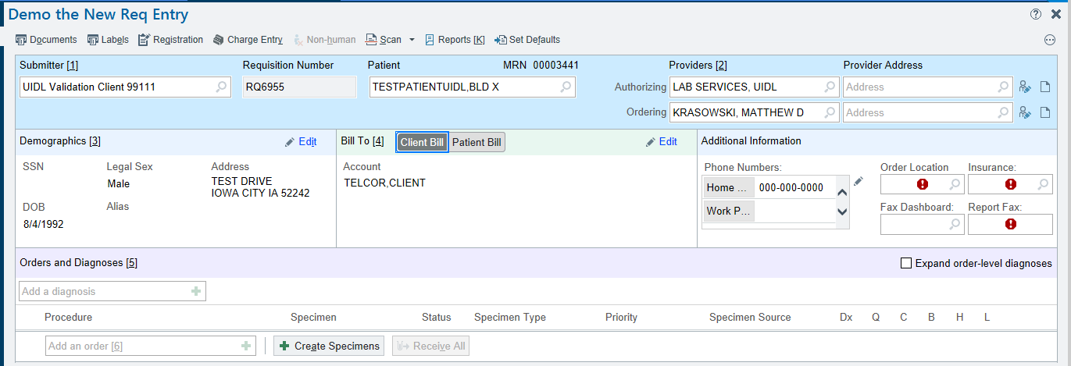  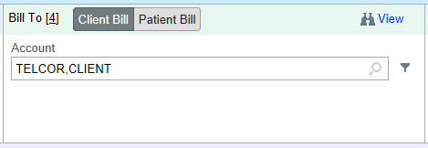
Additional Information:  There are several fields that may or may not be required depending on the submitter and ordering department.  The patient phone number may be entered here.  Fill out required drop down fields. | 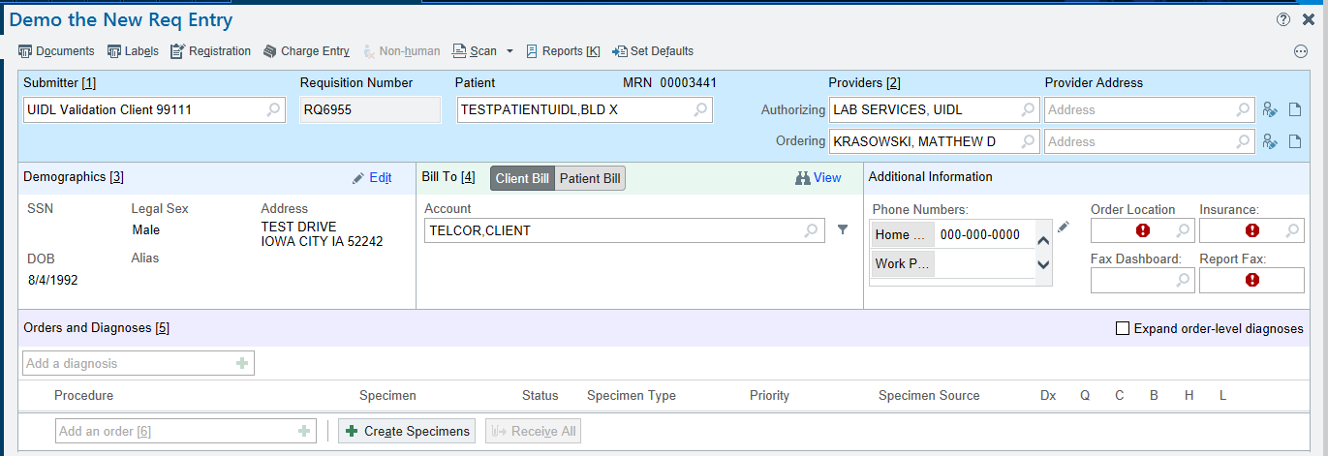
5. A diagnosis code may be entered but is not required.  The diagnosis can be typed into the field or can be searched by clicking the add icon.   Selected diagnosis codes will display on the bar by the diagnosis entry field.  Note: Individual ICD10 codes can be assigned to individual tests under the Expanded Order Level Diagnosis. | 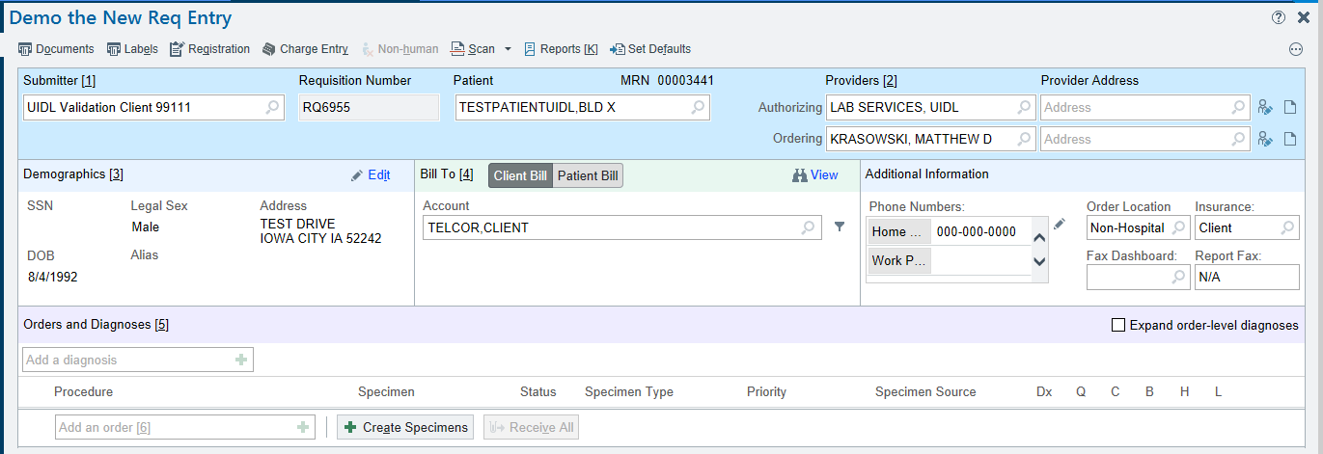  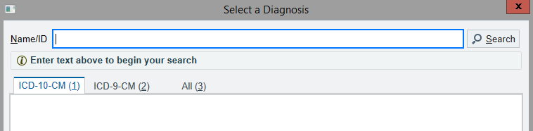  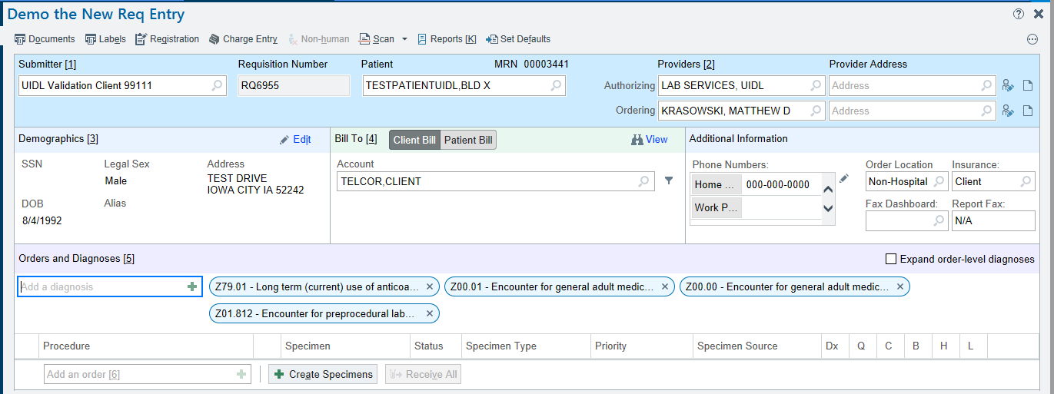  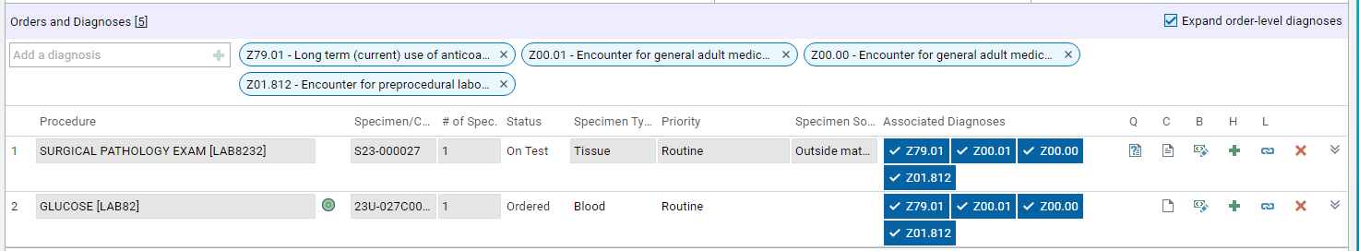
6. Enter a procedure/test order in the Add an order field by entering the name or test number.  Note: There is a 30 procedure limit before screen shifting occurs.  Note: When an AP test order is placed the Case Builder and Cancel Orders buttons become available. | 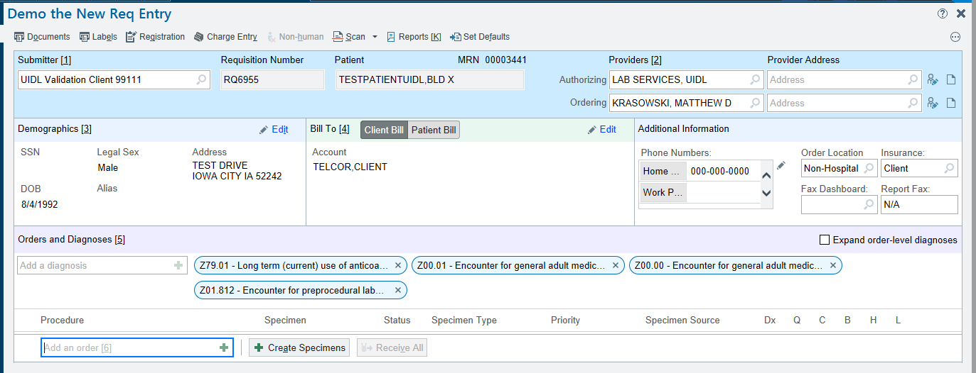  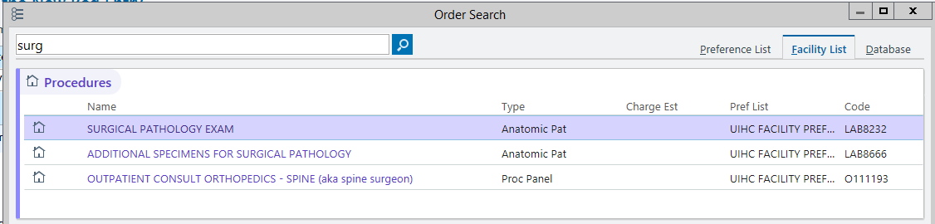
Click on the 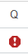 icon to enter the order questions for this testing.  The question cascade will open for the test, displaying all of the entry fields.  Note that the Order comments and Lab Order Comments entry fields are on the right side of the screen.  When the required questions are answered the question field can be closed by clicking the on the right side of the screen. | 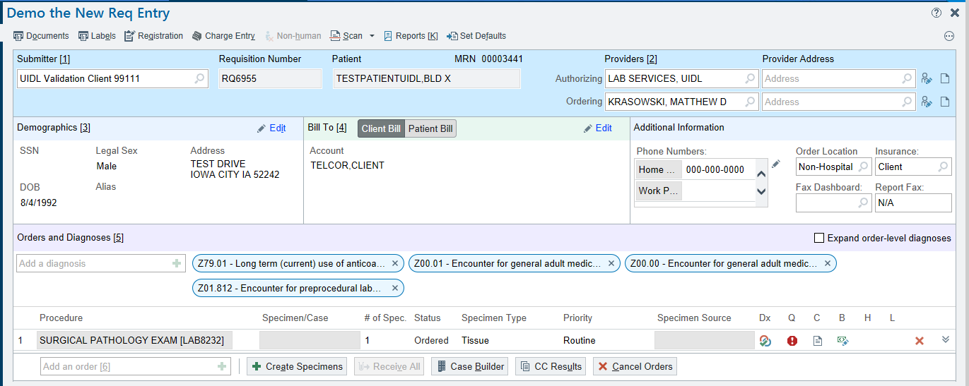  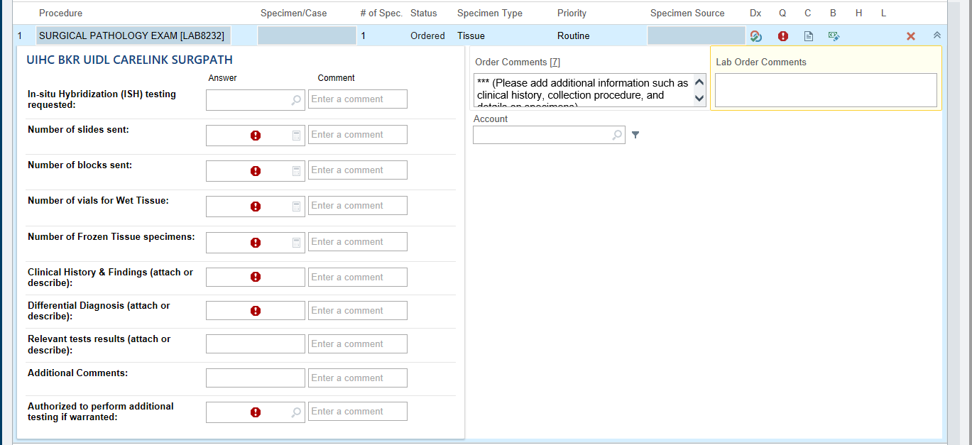
For AP cases click the Case Builder button. The case number is automatically assigned.  Note: This window has not changed from previous versions.  Enter information and click Save and Accept at the bottom of the window. | 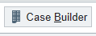  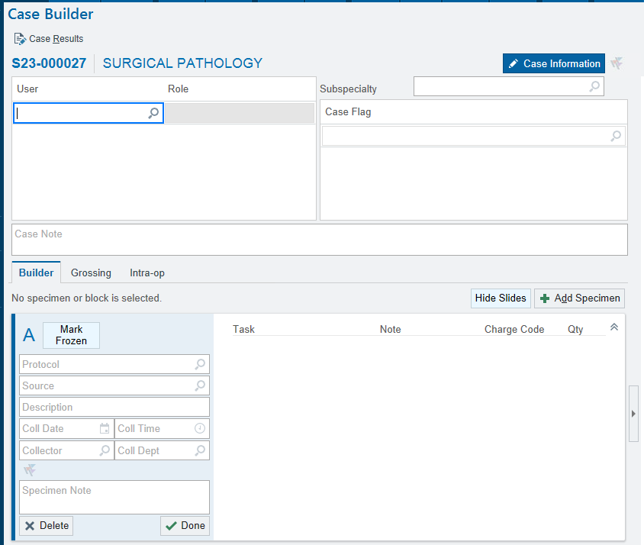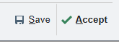
For CP cases, click the Create button to generate the accession number. Specimen numbers (also called “accession numbers”) will appear in the Specimen/Case fields.  Enter the Date and Time of collection in the indicated fields. You can type T and N for today and now. | 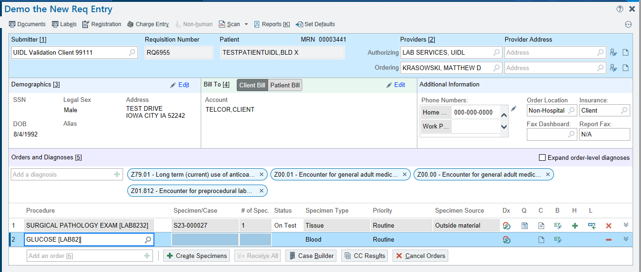  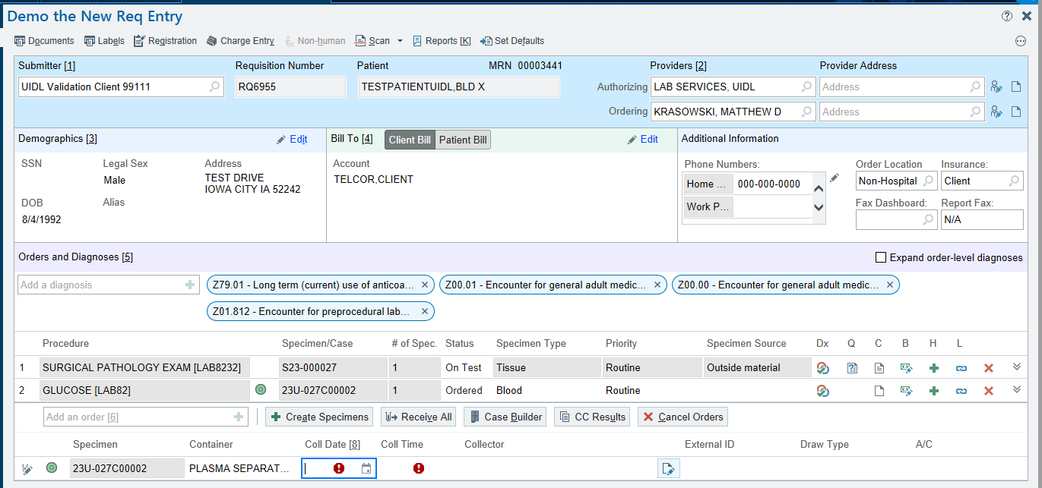
To update the CP test information, click the Specimen Update 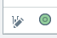 icon.  Fill in or change any information in the fields.  Click the Accept button in the upper left when finished.  Note: there is a direct link to the Add-On function on this screen. | 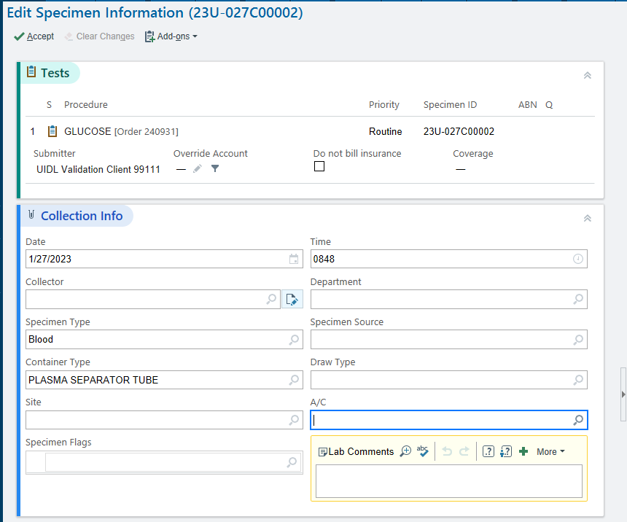
To remove testing, click the red X icons or the Cancel Orders button.  The red X icons are specific for removal of the listed line-item test.  The Cancel Orders button allows the selection of any test on the requisition to cancel.  Note: Completed testing cannot be cancelled.  To clear all information from the requisition and start over, Click the Clear button now located in the lower left corner of the screen. | 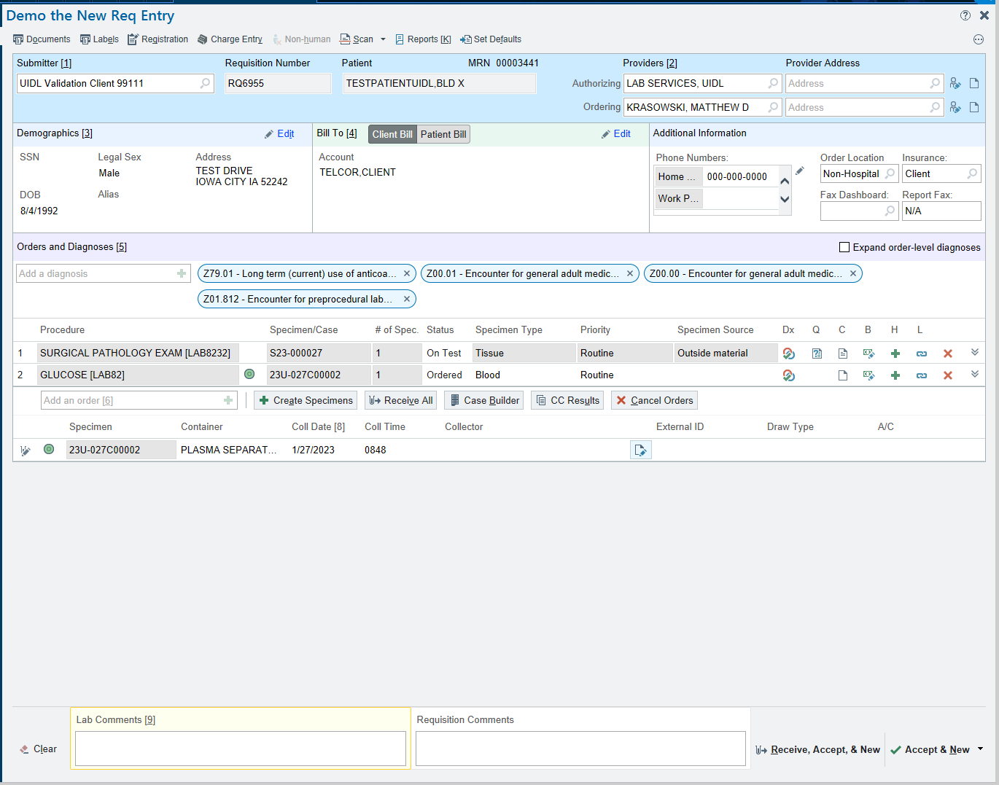  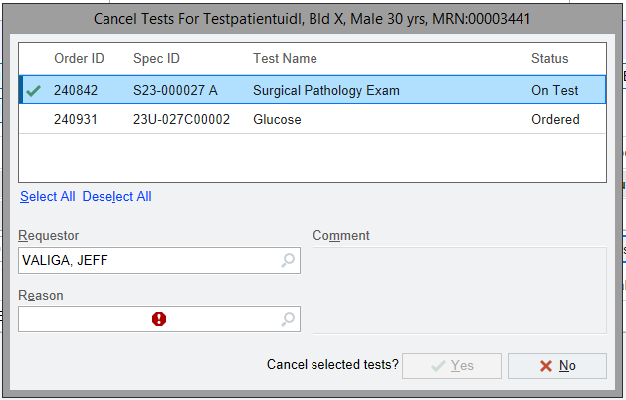
The Lab Comments field and the Requisition Comments field are both listed at the bottom of the screen. | 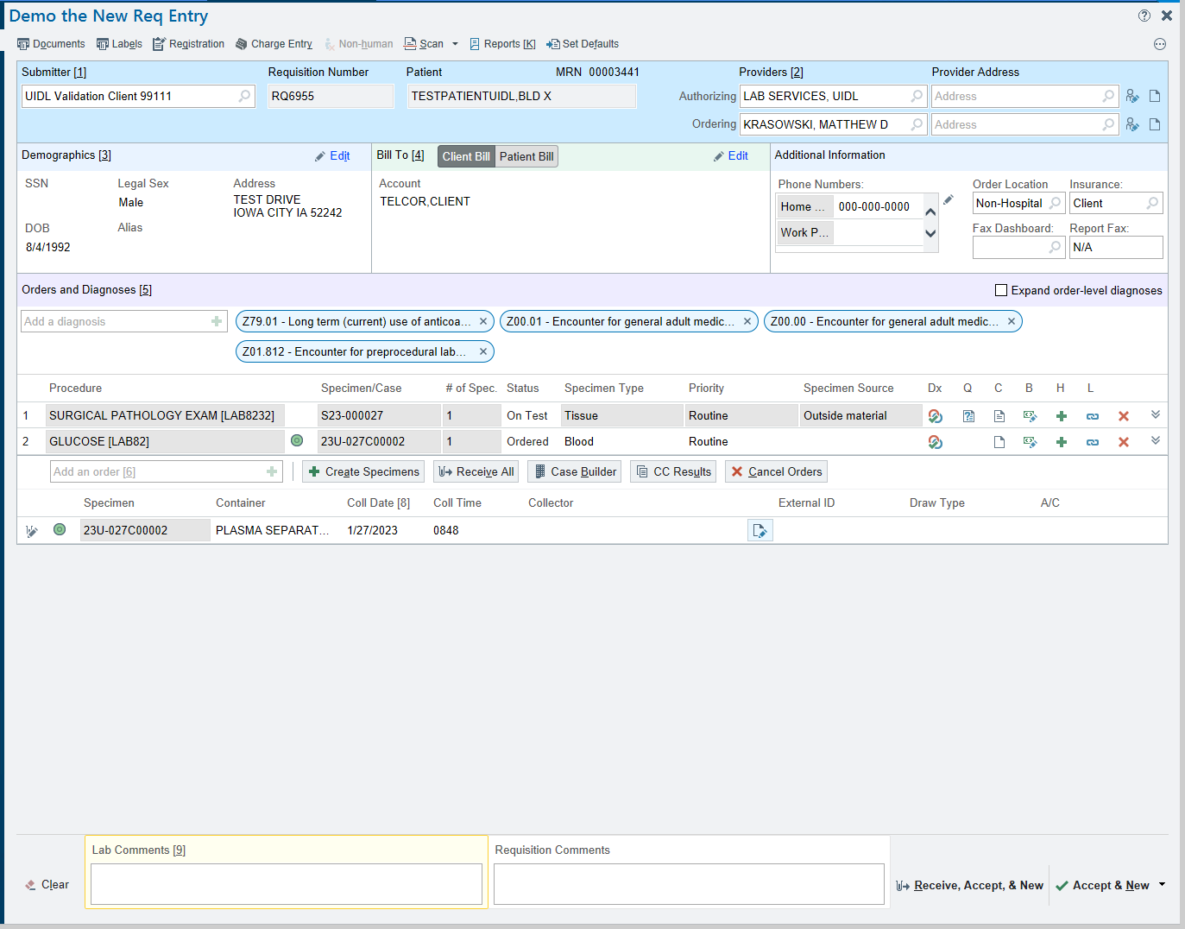
Scan any pertinent documentation into the Requisition by clicking the Scan button at the top of the screen.  Import the document picture files or scan directly and save the file.  Note: Cut and Paste option is no longer available. | 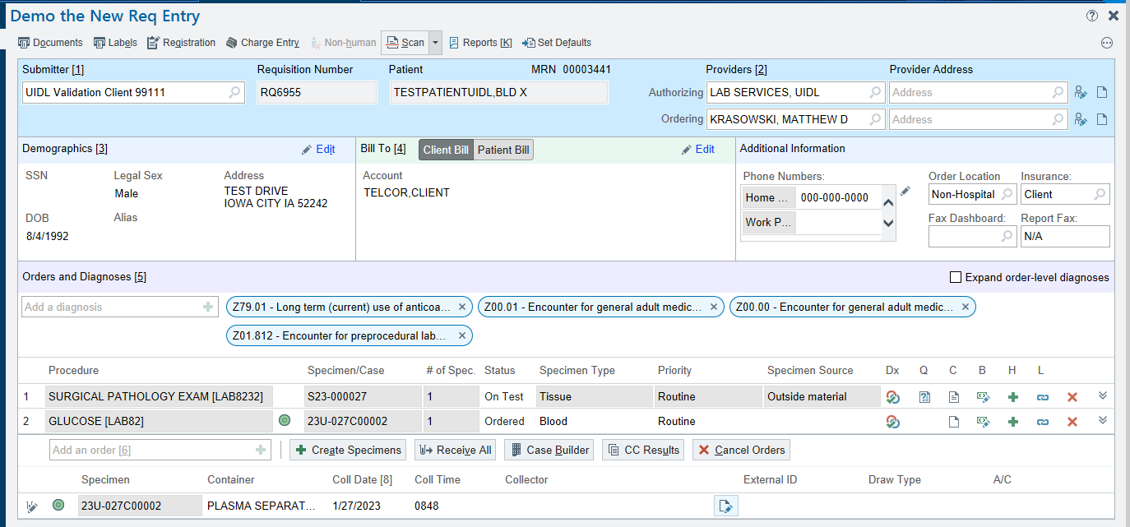  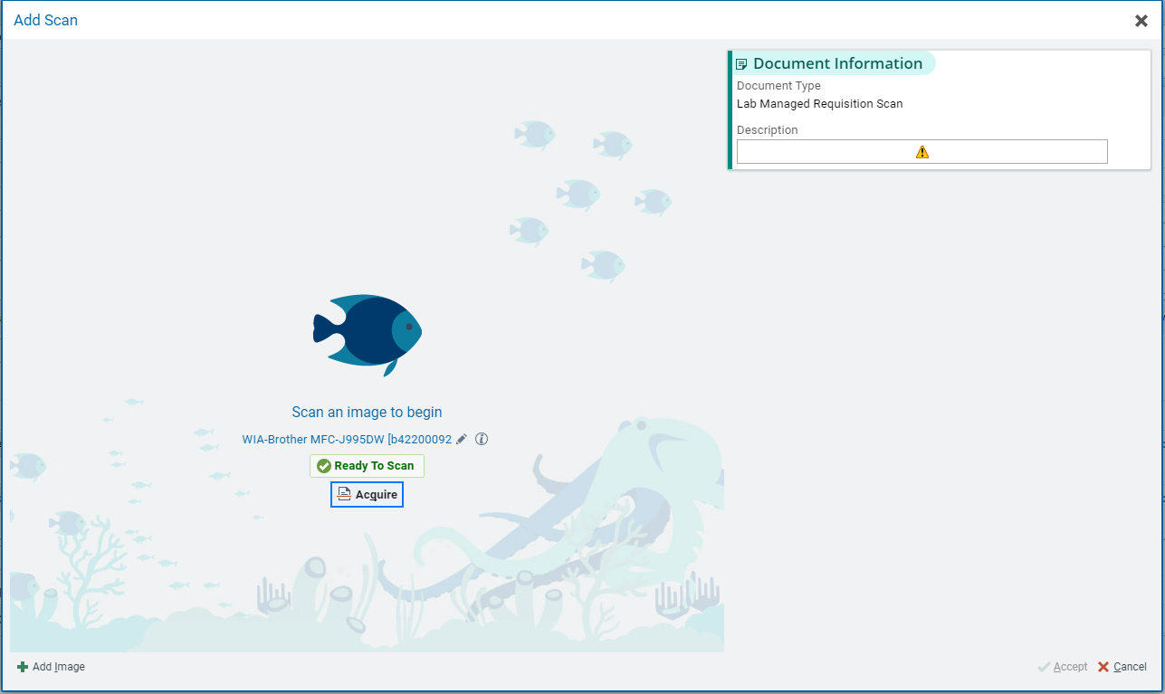
When all desired testing and information has been entered,  Click the Receive, Accept, & New or the Accept & New drop down at the lower right of the page depending on your department protocol. | 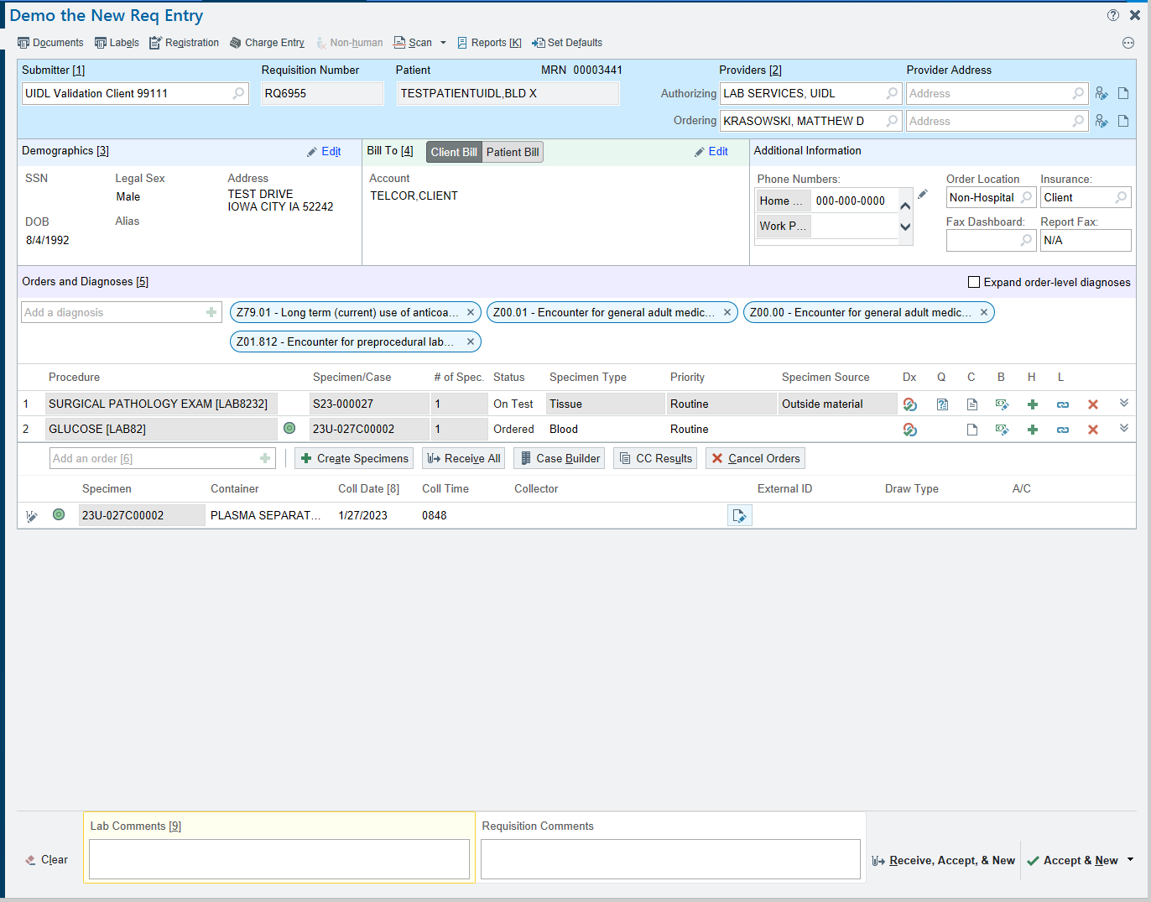  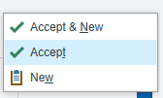
Extras:  A reports sidebar window can be activated by clicking the Reports button at the top of the page.  The sidebar window allows document upload like the Scan button as well as displaying information normally found in Requisition Inquiry. | 